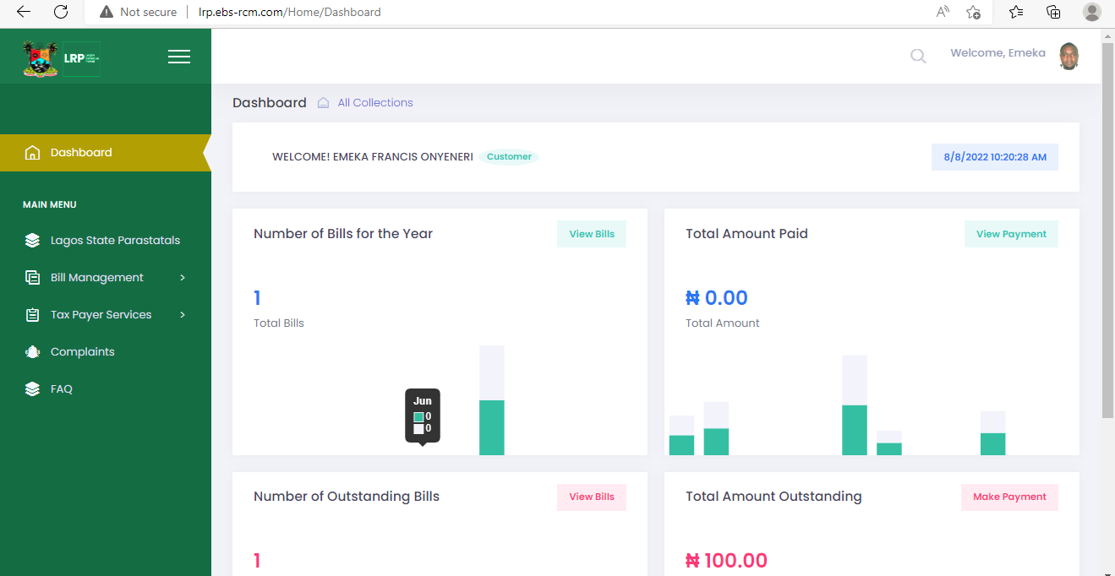

Menu list

Admin Module- Banks

1. Lagos State Parastatals
2. Bill Services

* Search/Download Bills

1. Bank Services

* Payer ID Creation
* Transaction Amendment Request
* Transaction Reversal Request

1. Approvals (Bank Admin only)

* Transaction Reversal Advice

1. Report Management

* Transaction Report
* Transaction Reversal Report
* Transaction Amendment Report

1. Administration

* User List
* User Creation/Deletion

1. Settings

## 16.2 Search/Download Bill – BANK MODULE

This is used by the bank staff to view and download the taxpayers’ bill history. This page should allow for the selection of date range and searching by Payer ID or Bill reference

**Process Flow:**

* Bank user logs in to the Admin module
* System sessions the corpid attached to the user profile
* User clicks on Bill Services/ Search or Download Bill
* Page is in two segments
* Upper segment contains a form for individual filter of bills that displays result in a grid
* Lower part displays grid containing search details
* User can click to view details of a bill to see the full details of the bill

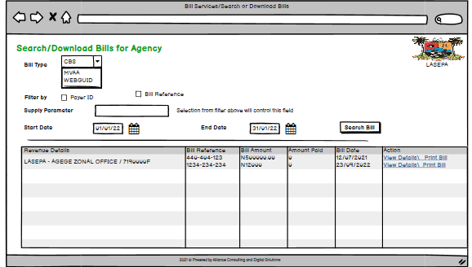

# 15.0 lrp process flow and design – Bank services

## 16.4 Transaction Reversal Request

The Transaction Reversal Menu is used to view send reversal request from the bank module for onward action by the relevant stakeholders. This should display a form where user can input details relevant to the request. This should be able to allow the requester get feedback and also send responses back to the admin.

The page should be divide into two segments. The up

**Detailed Requirements**

* Transaction Payer ID
* Full Name
* Transaction Amount
* Receipt Entry ID (Validate this to return Agency and Revenue name which will be displayed below)
* Agency Name (non editable)
* Revenue Name (Non editable)
* Comment
* Requested by (Payer Id of the user that logged in)
* Status: Pending, Receiving Attention, Under Review treated (this field is hidden on the form but visible on the grid after submission)
* Date Submitted (this field is hidden on the form but visible on the grid after submission= System Date)

